**IST471**

**Lab 3** (45 points)

**Theme: Advanced Subqueries – Multiple-Row & Multiple-Column Subqueries**

**Team Members & Contribution % (100% - FULL CONTRIBUTION)**

|  |  |
| --- | --- |
| NAME | CONRIBUTION % |
| Ethan Flores | 100% 100% |
| Manny Tapia | 100% 100% |
| Tyler Brown | 100% 25% |
| Alexa Schnetzler | 100% 25% |
| Taylor Bevis | 100% 75% |
| Larryon Johnson | 100% 75% |

Instructions: You are to create **multiple-row** subqueries for Problems 1 – 4. For the multiple-row subqueries, you must use **multiple-row comparison operators (ANY, ALL, or IN)** in your queries. For Problem 5, a **multiple-column** subquery is required.

1. Find out those books (in any category) that have a retail price **less than the highest retail value** of the cooking books. (8 points)

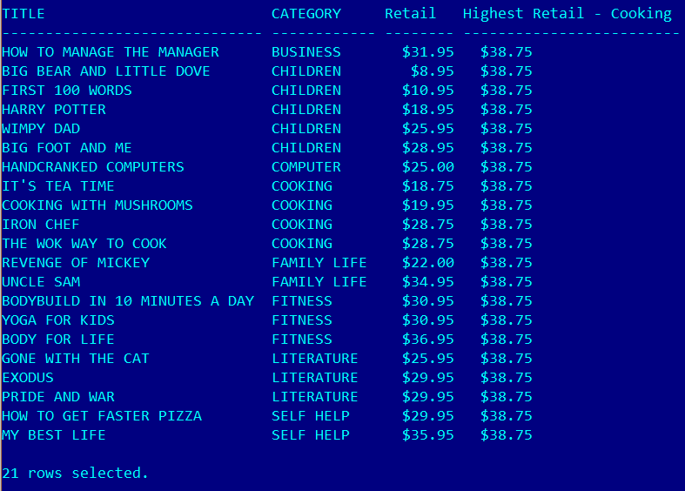

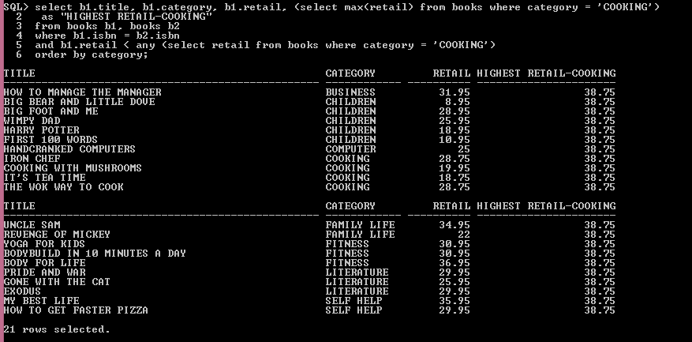

1. Find out those computer books with a retail price **higher than the highest retail value** of the FITNESS books. (8 points)

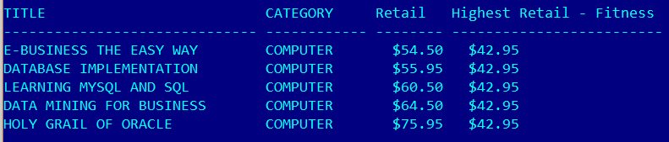

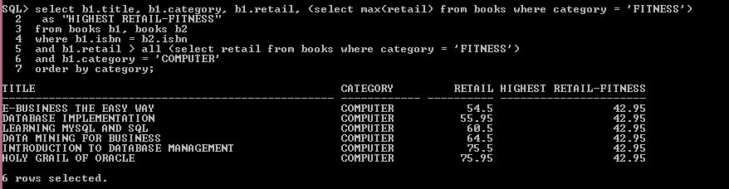

1. Searches for the books purchased by the customers who also purchased the book with ISBN 0401140733. Some books could have appeared on more than one order. Hint: We should first identify what orders contain the book with ISBN 0401140733. (8 points)

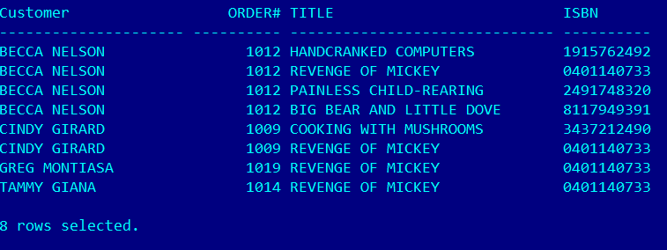

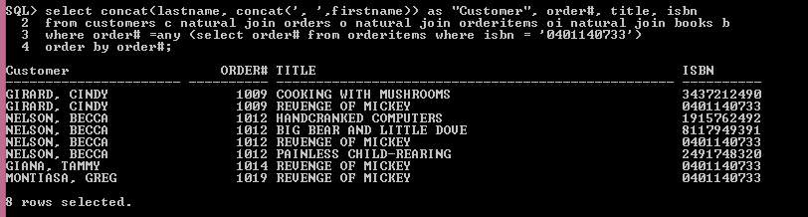

**Challenging Problems**

1. Find out those customers (from any state) who have a total amount due **greater than** the **highest** total amount due for the **customers living in Florida**. In other words, the book store manager wants to know who owes more than all of those customers who live in FL. (11 points)

NOTE: total amount due = SUM(quantity*paideach)

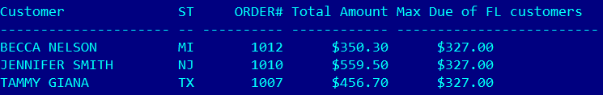

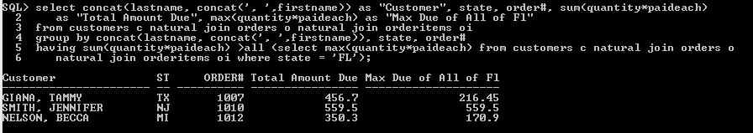

1. Identifies the book(s) with a highest retail value in its own category. (10 points)

